* Create an account on Amazon: <https://console.aws.amazon.com>
* Select a region from the drop down of countries where Amazon has servers. (Right up)
* Look to the top left, click on services and select the EC2
* Click the EC2 dashboard to get an overview of the resources
* Either you scroll down or look to the left (Instances section), click to launch
* Follow screenshots:

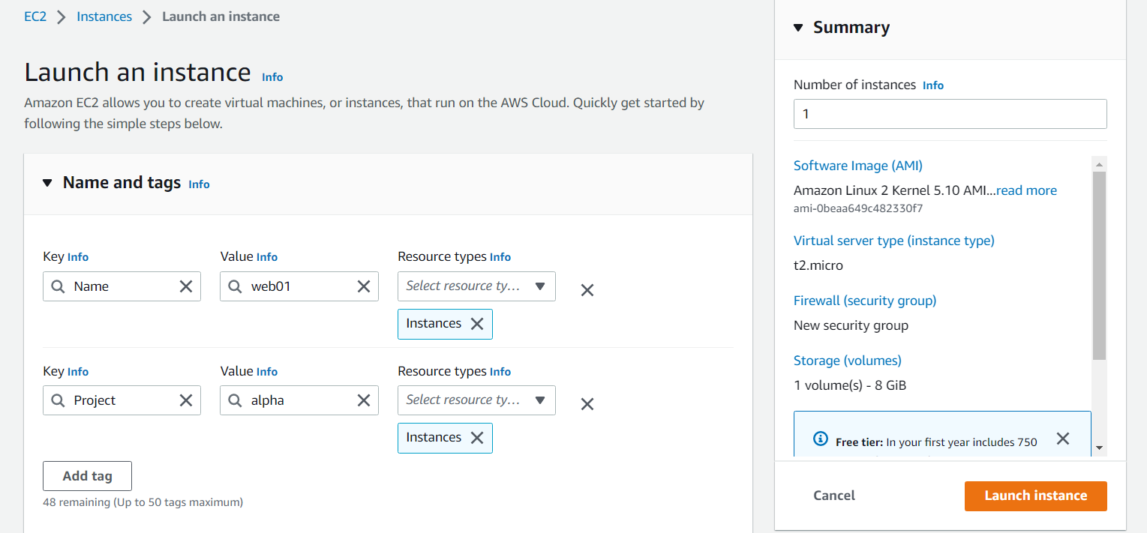

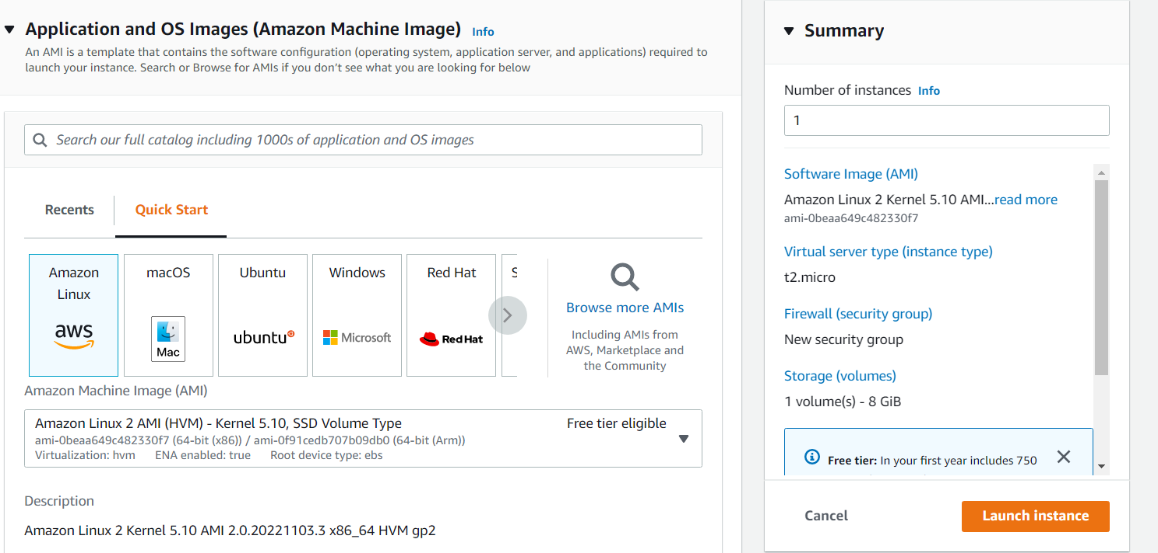

Select Ubuntu, if you want another AMI, click browse more AMIs. Becareful as some AMI aren’t free. You will be charged for the software. Click on AWS Market place AMIs

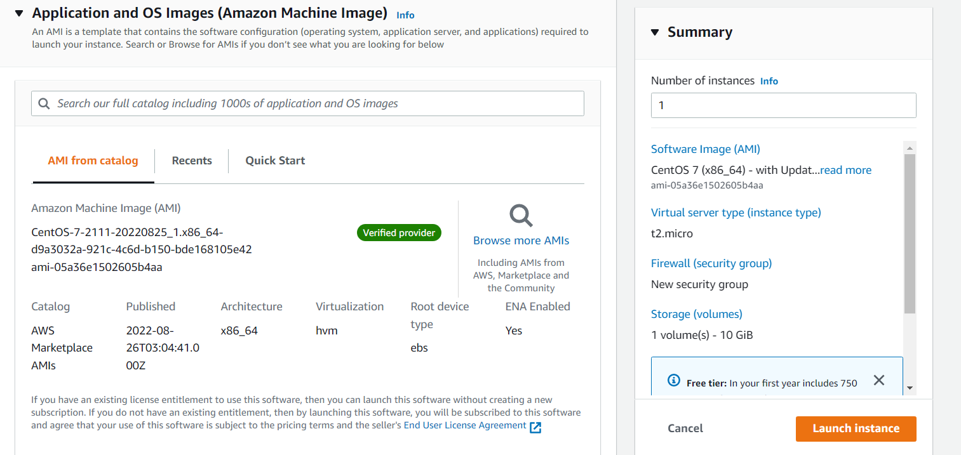

* Select your Instance Type according to the application you will be hosting
* Create a Key pair for ssh logins

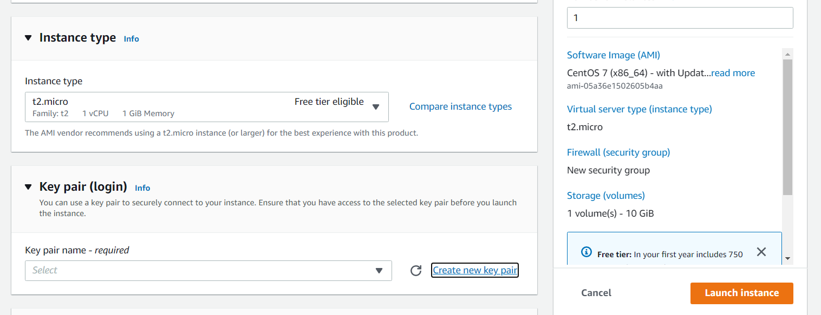

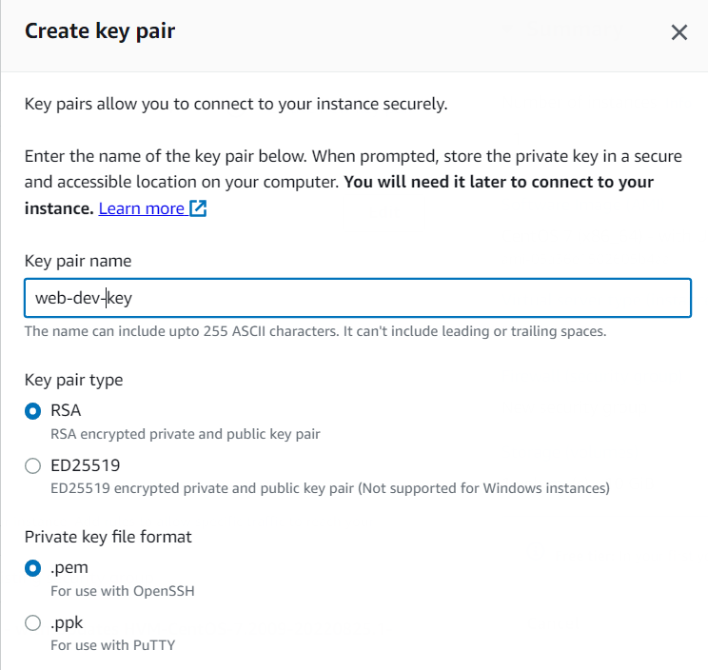

* Create a security group by clicking on edit. Note: It is the virtual firewall of the Instance you are creating

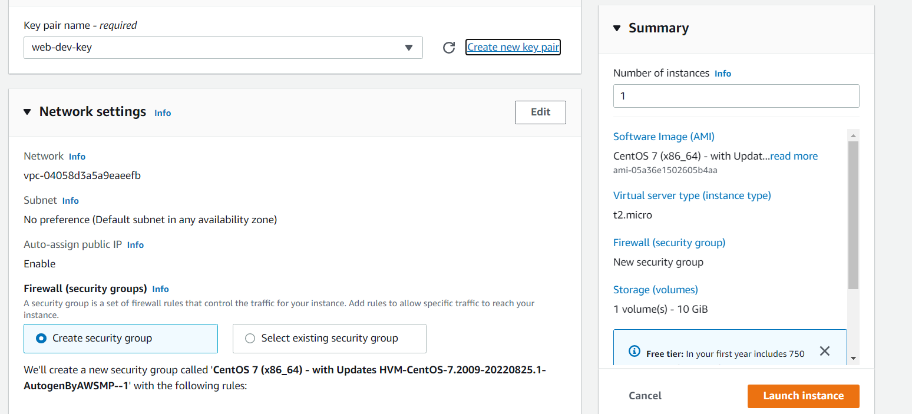

* Select the default vpc, the subnet is the region where your network interface will be hosted… Select same region as your instance
* Give a name and description

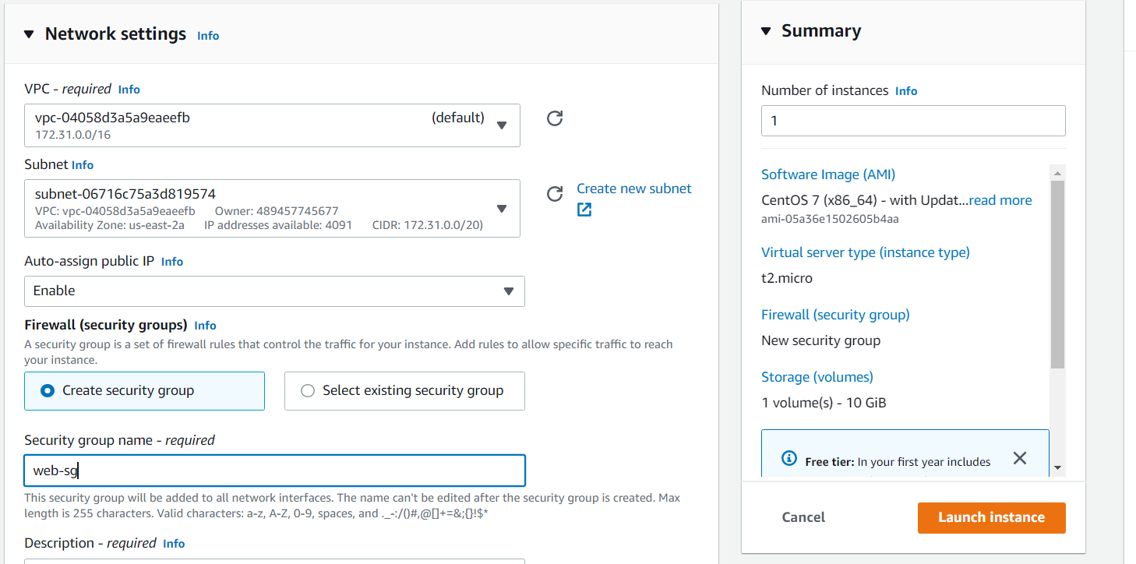

* Give settings to only the inbound rule and don’t touch the outbound rule.
* ssh should be only from your ip and any other approved ip range
* Click on more rules, custom TCP can be approved as anywhere

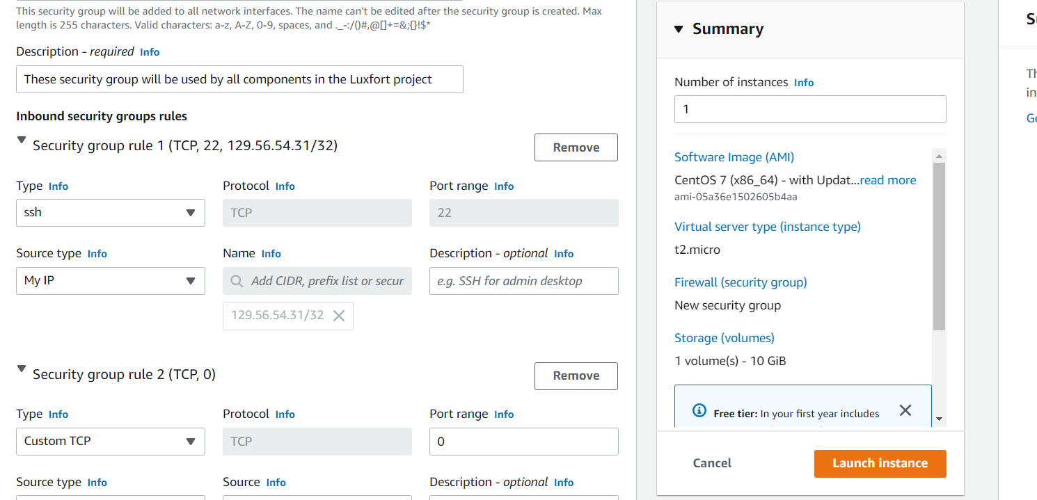

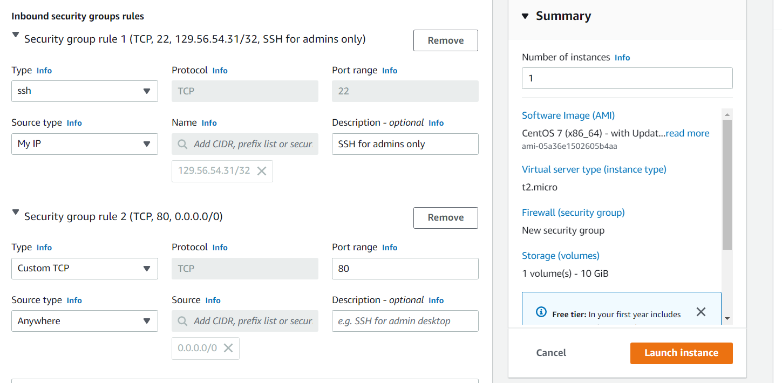

* Configure your storage option and click on Advanc details

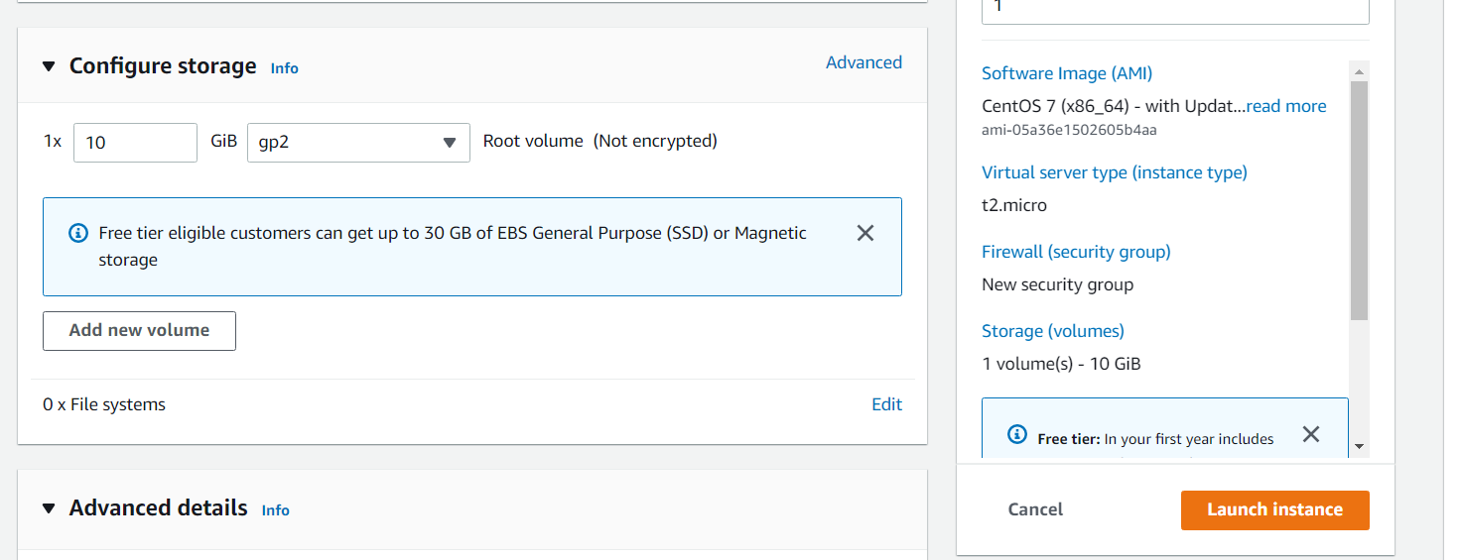

* Scroll down to end, the user data is used to provision your instance
* Then, finally click on launch instance

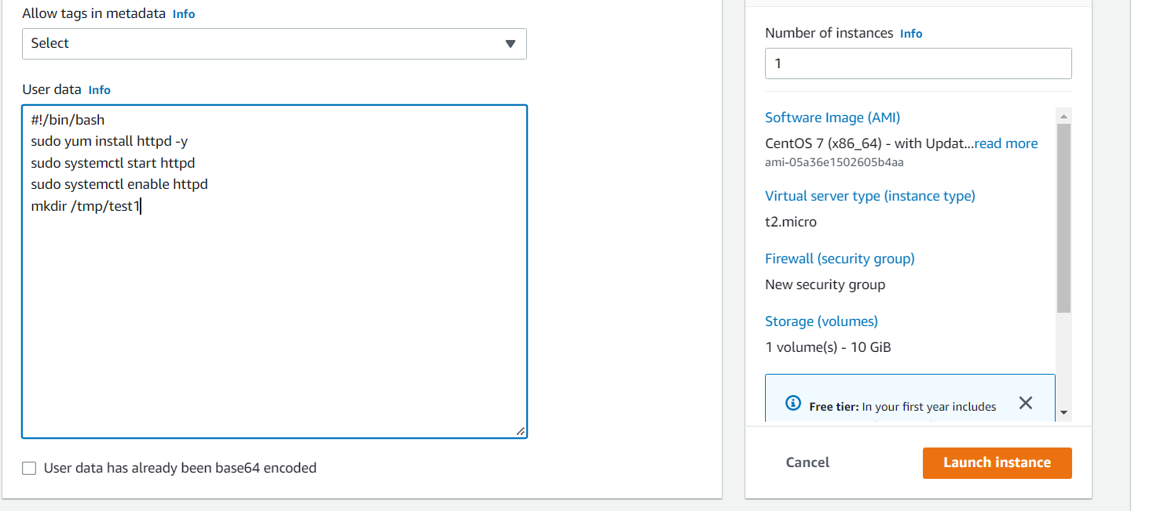

* Click on view all running instances at right below side

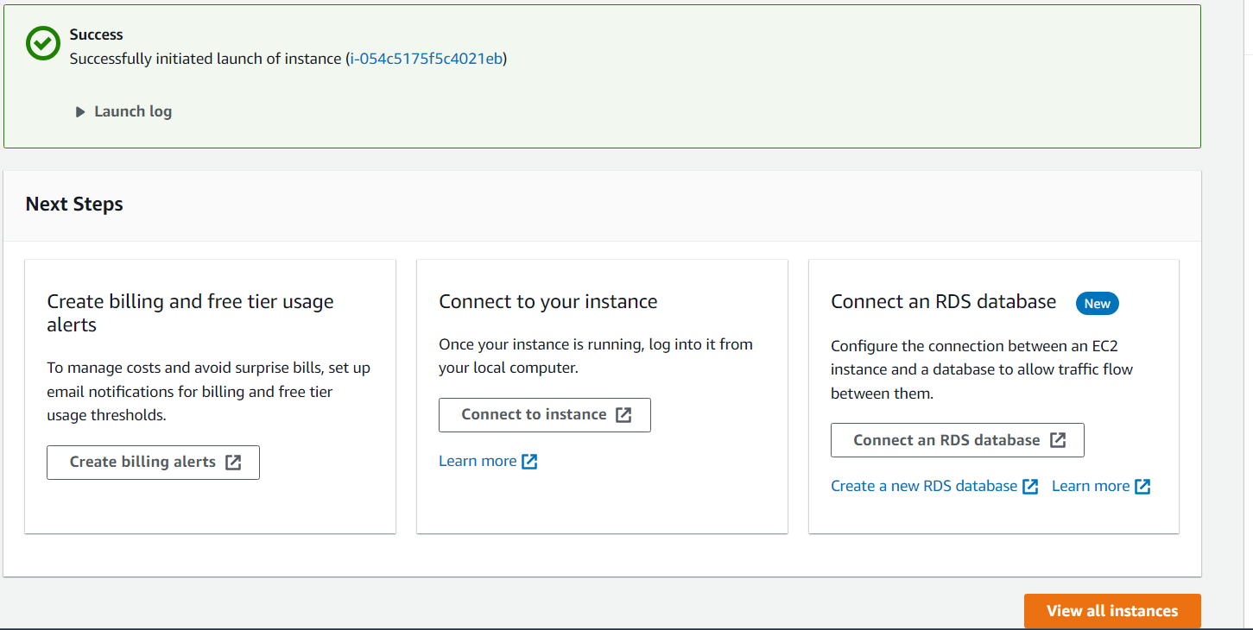

**Connect to your Instance**

* Select your Instance and click connect
* Select SSH client
* Go to your git bash, type pwd to know the dir you are in
* Make sure the key pair is in the same dir
* Copy the public ip of your instance
* ssh –i Desktop/keypairs/web-dev-key.pem [centos@18.118.7.247](mailto:centos@18.118.7.247) (If you are having issues with SSH, go to the security group you created for the instance and change (SSH from my IP) to (ALL TRAFFIC from Anywhere) to check.
* Make sure you add another inbound rule of custom TCP from anywhere(IP) so as it can be accessible from browsers
* Systemctl status httpd ……… to check the provisioning on the instance
* Curl <http://localhost>
* Get the public IP of your instance and load it in a browser